**Welcome Back**

It has been an excellent start to the year, and we are so pleased that everybody, including our new Reception children have settled in so well. Our Year 6 children have already become excellent and supportive buddies to them.

**Dates for your diary**

Tue 1st October 4-5.30pm New Starters Open Evening

Thursday 17th October Year 6 and Reception library session

Monday 21st-Wed 23rd Phonics workshops for Reception

Tue 22nd October KS1 Parents’ Evening

Wed 23rd October KS2 Parents’ Evening

Thursday 24th October Y1 and Y2 library session plus Own clothes day (£1 for school funds)

Friday 25th October Harvest and celebration assembly

We finish for half term on Friday 25th October at 3.20pm.

Appointments for Parents’ Evening will be sent nearer the time.

**Reminders:**

PE kit should consist of the correct coloured t- shirt (or a normal school polo shirt) with plain shorts, leggings or tracksuit bottoms. If a tracksuit jacket is worn instead of a school jumper it should be plain with no stripes, patterns etc. we are seeing some children wearing trainers for school, and these are not part of school uniform. Please ensure your child has correct plain school shoes.

Earrings should not be worn for school. If they have to be worn, they must be small, plain studs only and need covering for PE.

**Attendance and punctuality**

Thank you for an excellent start to the term in regard to attendance and punctuality. The side gate closes at 8.50am and after this children will be marked as late. These lates are recorded and passed on to the local authority as we are required to do. Please remember to contact us on every day that your child is absent.

Also, just a reminder that the fines for taking children out of school have now increased.

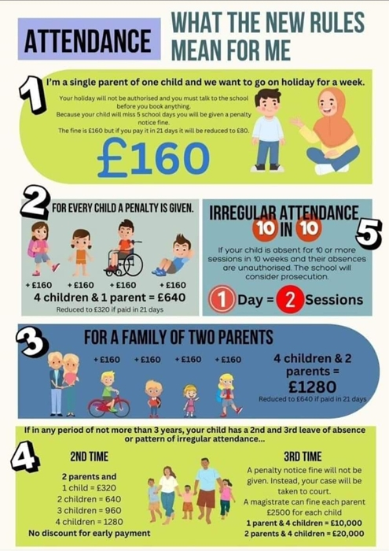

Attendance for September:

|  |  |
| --- | --- |
| Reception | 92.5% |
| Year 1 | 95.7% |
| Year 2 | 93.7% |
| Year 3 | 92.0% |
| Year 4 | 96.5% |
| Year 5 | 94.7% |
| Year 6 | 94.6% |

Our whole school attendance in September: 94 % Well done to Year 4 for the best attendance in September!

**Help and support**

Earlier in the term I sent out a letter to Year 3 and Reception about applying for pupil premium, even if your child got free school meals in KS1. This ensures that we receive extra money in school which can be spent on supporting all our children.

The link is here: <https://www3.halton.gov.uk/Pages/EducationandFamilies/Schools/FreeSchoolMeals> However, I also wanted to make you aware of a scheme which you can use if you use breakfast or after school clubs. This provides up to £2000 a year to help with the cost of childcare. I hope this will be of help to some of you.

<https://www.gov.uk/tax-free-childcare>

**Seesaw**

All of the information that your child needs for home will be available on the class Seesaw.

Homework is also set on this site so please ensure you keep up to date with what your child should be doing that week. A seesaw log in is required to keep up to date with all of our school news. The first newsletter of the year is the only paper copy that is sent out. After this, all newsletters will only be on Seesaw or on the school website.

**Reading**

Reading is the most important thing that you can do with your child to help them make progress. Please make sure that you are reading with them daily. However old your child is, they love hearing you read to them too! Children learn between 4 and 12 thousand new words a year through reading. We plan on having lots of fun reading activities throughout the year to promote this especially as we have our wonderful new library in use now. Look out for an invitation to come and see it with your child.

**Trips and visits**

We are already planning a variety of interesting trips for children to go on this year and you will receive letters about these in due course. All school trip money will now be payable via School Hub rather than handing cash into the office. This is hopefully much easier for you. Details will follow with trip letters.

**Clubs**

We have already begun with some of our clubs for the year and others will follow. **However**, I just want to inform all parents that clubs are a privilege. If children are not displaying the behaviour that we expect in school, or in clubs then this privilege can be taken away. **We will not allow bad language or inappropriate behaviour to spoil clubs for other children.**

**Allergies and packed lunches**

A reminder that we have children in school with a variety of allergies. Therefore, children must not bring any nuts or nut related items in packed lunches. This includes peanut butter, hazelnut spread including Nutella etc. However, you can get nut free versions of this. Also please ensure children’s lunches are healthy as possible with no sweets or chocolate bars.

**Welcome**

It has been lovely to welcome Mrs Geraghty as our new Year 6 teacher, along with some new staff who are working with particular children. Miss Burgess has also joined Year 6 this week as the teaching assistant to replace Mr Davies who has moved on to a teaching post elsewhere.